Image | 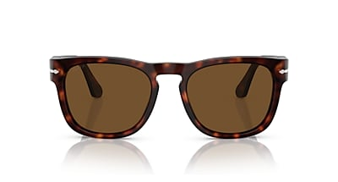
Brand | OLIVER PEOPLES
Model Name | Elio
Price | RS 4399
PRODUCT DETAILS

